Final Project

Reconstruct 3D from stereoscopic images

and colorize 3D point cloud

How to get the 3D point cloud:

1. Load pictures of right camera and left camera.
2. Pick every image and scan every row from top to bottom. If R channel value of the column is bigger than 230 and the most biggest, pick that pixel.
3. After doing step2, we will get the pixels which are on garden gnome
4. Pick the point of right side view, and calculate its epipolar line.
5. Find the point which is the most closest to the epipolar line, then we can obtain the point of right side view and it corresponding point in the image of left side view.
6. We can get projective matrix by K and [R|t], then use following equation to obtain 3D point cloud.

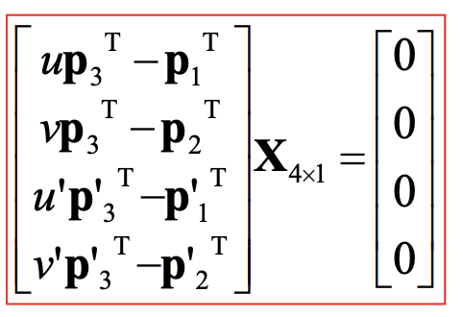

1. Import xyz file to Meshlab.

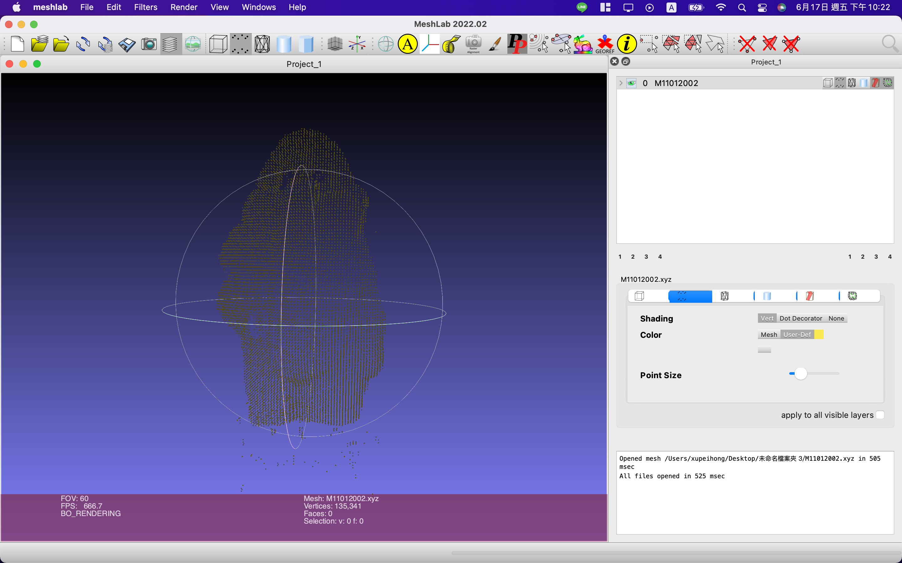

How to colorize 3D point cloud:

1. Use XnViewMP to pick seven points from TextureImage.JPG, and store there x value and y value.

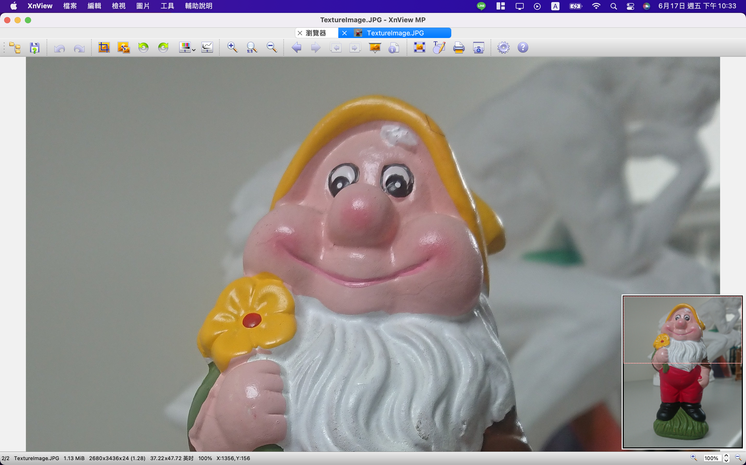

1. Use Meshlab to pick seven points from 3D point cloud file, and store there x, y and z coordinate.

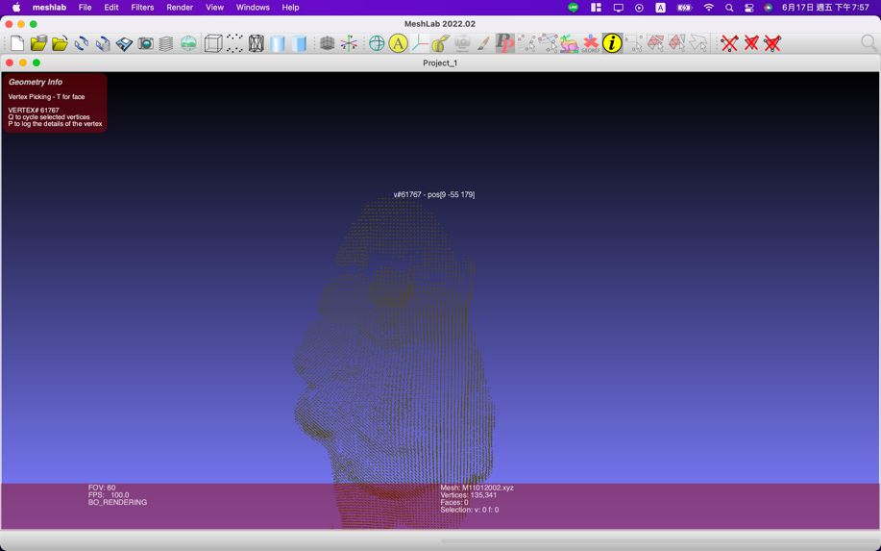

1. Use xy value of image and xyz value of world coordinate to solve projective matrix.

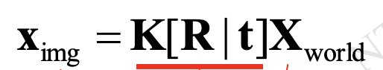, K[R|t] = P, 3D points = X1,X2…X7

2D points=[u1,v1],[u2,v2]……[u7,v7]

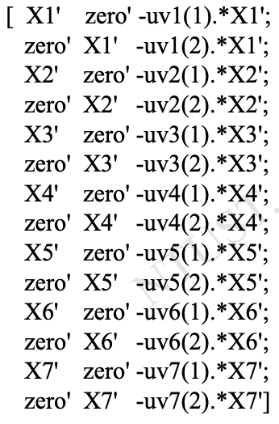\*P = [0]

1. Finally, use P\*X and we can get X’s corresponding point in TextureImage.JPG, then store its RGB value.
2. Use Meshlab to verify the result.

